Throughput Accounting

**Question 1**

WR Co manufactures three products, A, B and C. Product details are as follows:

**Product A Product B Product C**

$ $ $

Sales price 2.8 1.6 2.4

Materials cost 1.20 0.60 1.20

Direct labour cost 1.00 0.80 0.80

Weekly sales demand 4000 units 4000 units 5000 units

Machine hours per unit 0.5 hours 0.2 hours 0.3 hours

Machine time is bottleneck resource and maximum capacity is 4000 machine hours per week. Operating costs including direct labour costs are $10,880 per week. Direct labour workers are not paid overtime and work a standard 38 hour week.

**Required**

Determine the optimum production plan for WR Co and calculate the weekly profit that would arise from the plan.

**Question 2**

Will and Grace operate separate divisions making and selling products with identical cost structures.

Sales price per unit $50

Direct materials per unit $12

Direct labour per unit $8

Fixed production overheads of $200,000 per month are absorbed across the normal production level of 10,000 units per month. In each division assume a bottleneck capacity of 20,000 hours.

In April, Will makes and sells exactly 10,000 units whilst Grace makes 12,000 units and sells only

9,500.

Neither Will nor Grace has any opening or closing inventory of raw materials or components.

**Required**

Show which manager would benefit if bonuses were given on

(a) Profit

(b) Throughput accounting ratios

|  |  |  |
| --- | --- | --- |
| 1. |  |  |
|  |  |  |
| 2. |  |  |
|  |  |  |
| 3. |  |  |
|  |  |  |
| 4. |  |  |
|  |  |  |
| 5. |  |  |
| 6. |  |  |
|  |  |  |
| 7. |  |  |
| 8. |  |  |

**Question 9**

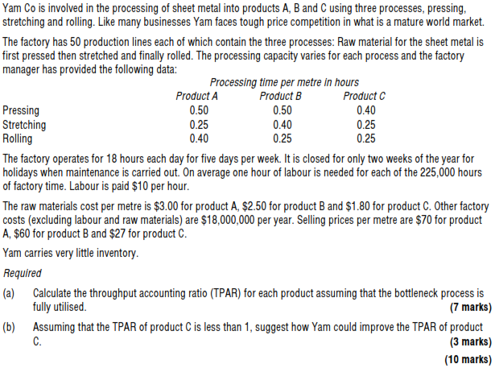

|  |  |  |
| --- | --- | --- |
| 10. |  |  |
|  |  |  |
| 11. |  |  |
| 12. |  |  |
|  |  |  |
| 13. |  |  |
|  |  |  |
| 14. |  |  |
|  |  |  |
| 15. |  |  |
|  |  |  |
| 16. |  |  |
|  |  |  |